 Reducing and Applying functions to images

## Load and filter an image collection:

USGS 8 TOA Reflectance (Orthorectified)

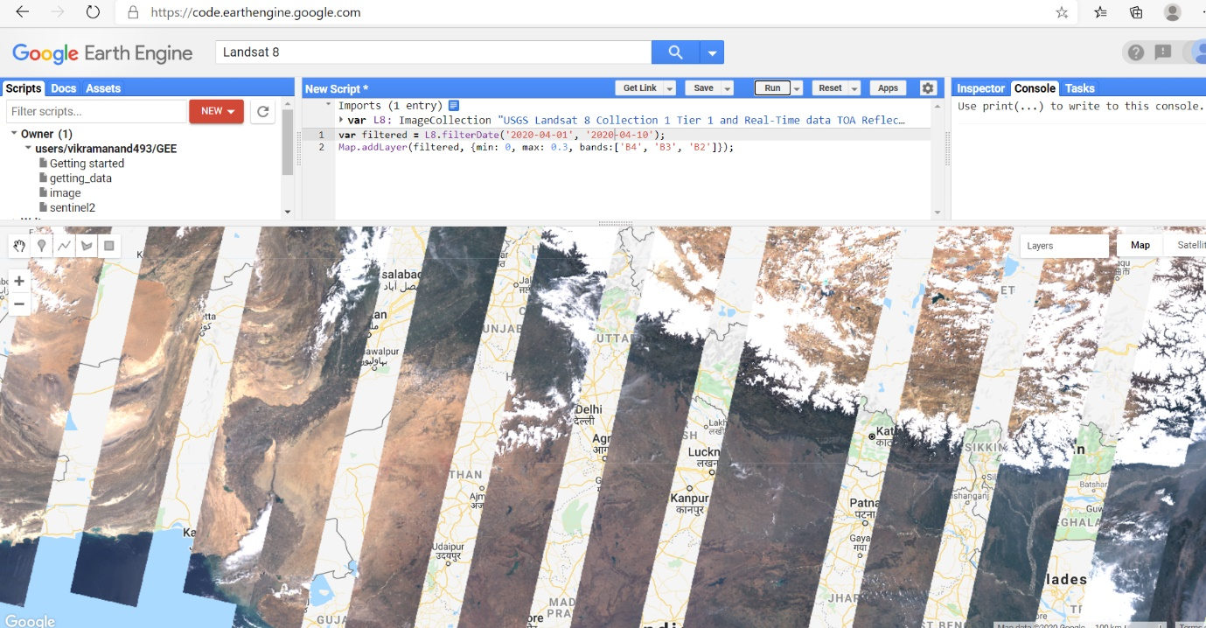

## 2.Making use of image band combinations

modify the bands to create the classic false ­colour look, with vegetation highlighted in red, and demonstrate giving each layer a name.

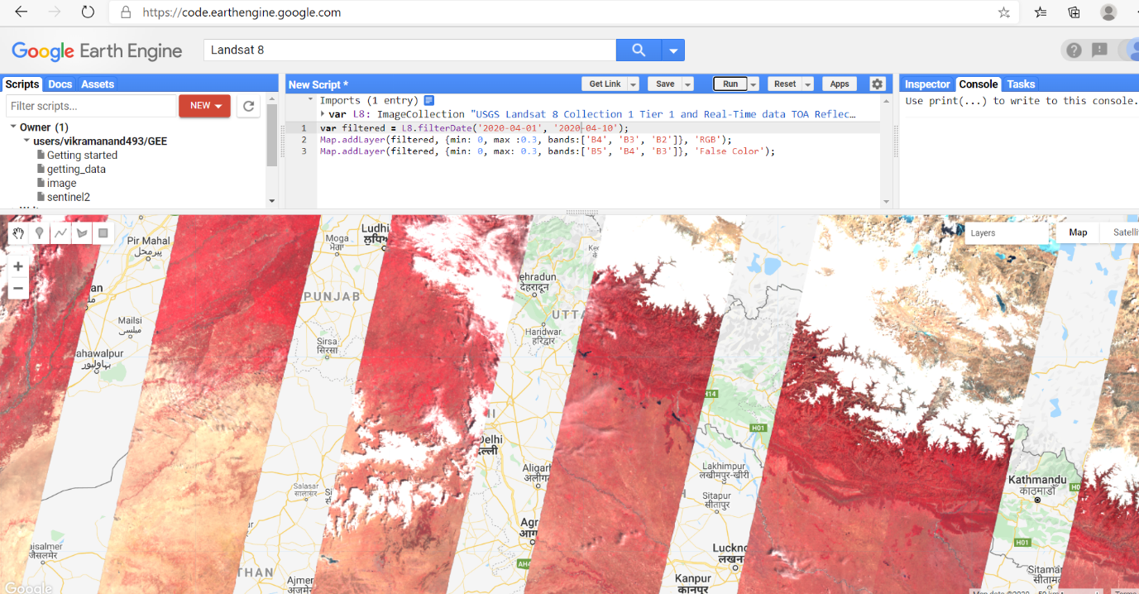

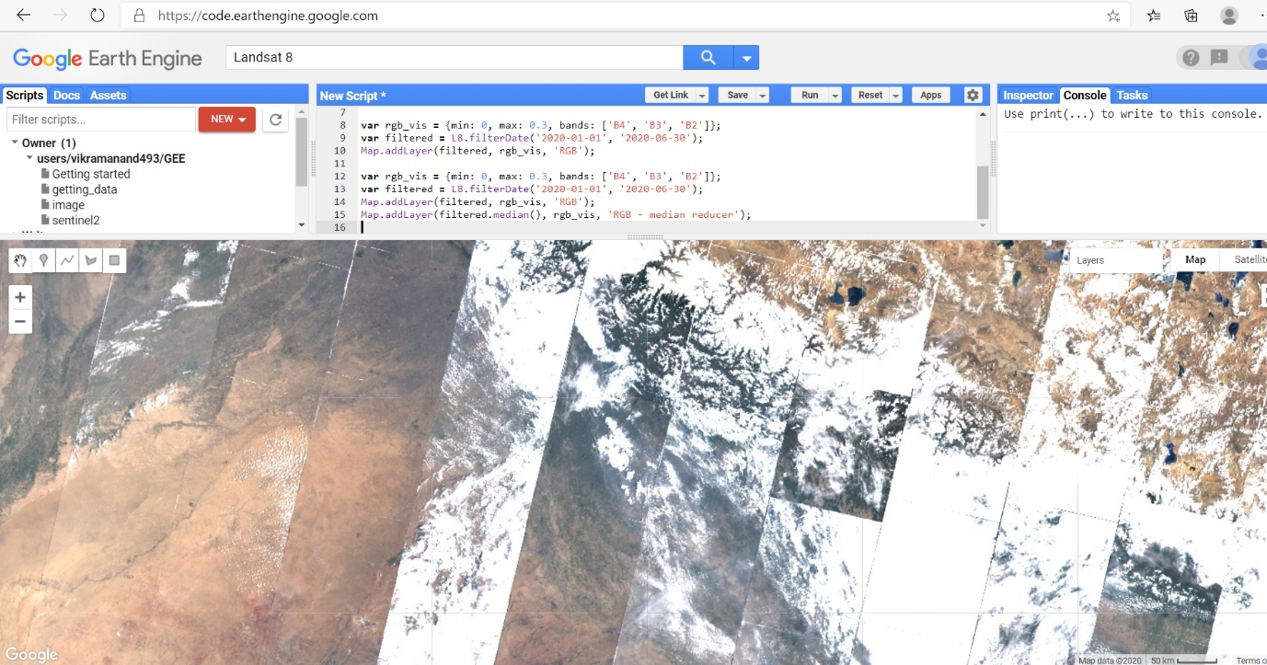

## Reducing image collections

## C:\Users\vikra\AppData\Local\Packages\Microsoft.Office.Desktop_8wekyb3d8bbwe\AC\INetCache\Content.Word\reducing.png

4.Isolate an Image

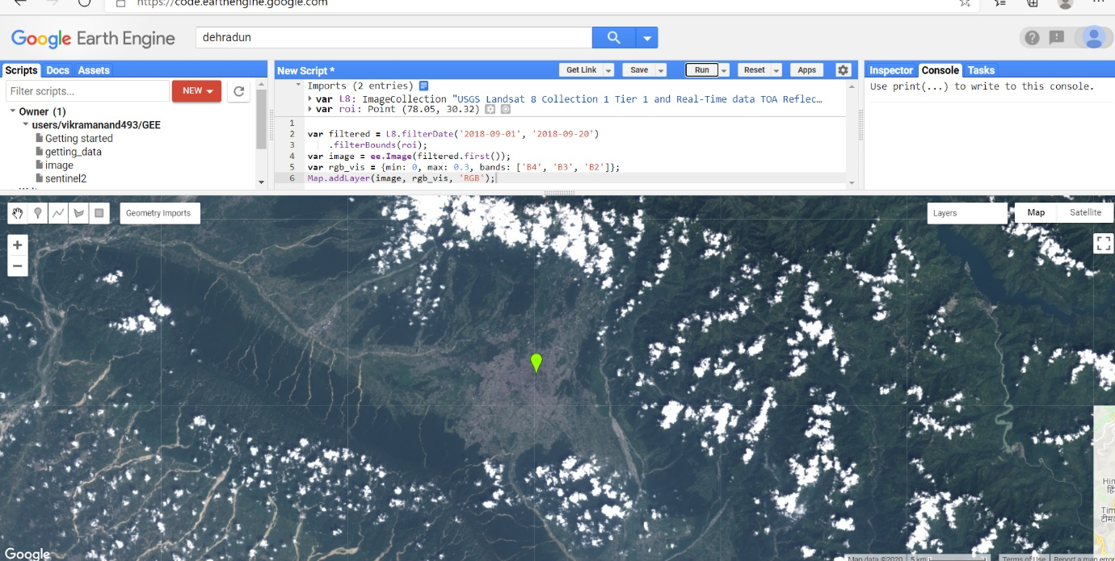

5. Compute NDVI

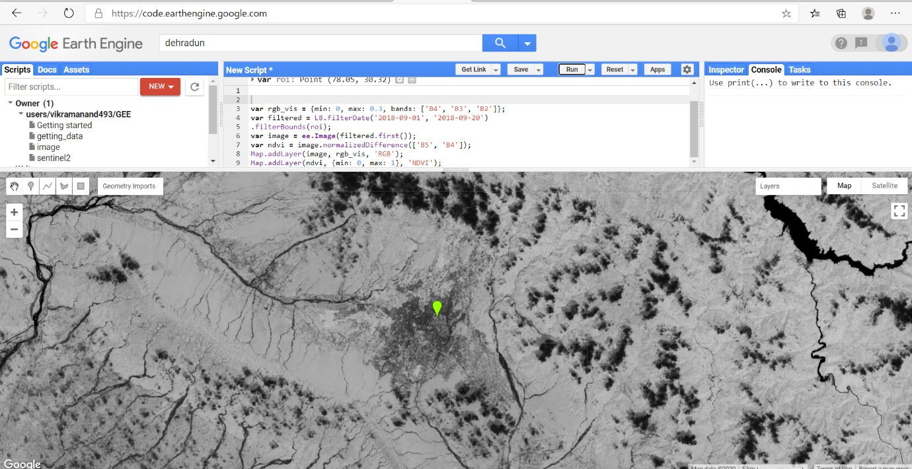

## 6. Writing a Function

## C:\Users\vikra\AppData\Local\Packages\Microsoft.Office.Desktop_8wekyb3d8bbwe\AC\INetCache\Content.Word\function.png

## 7. Charting NDVI over Time

